Essential Measures to Enhance Machakhela Protected Landscape Management Effectiveness
Project implementation REPORT
Prepared by Irakli Goradze, Project manager.
Duration: 14 December 2023 – 14 April 2025
Budget: EUR 108,796.70

1/ Background – development challenge
Machakhela Protected Landscape covering the area of 4295,5 hectares, is managed by the Khelvachauri Municipality through the Machakhela PL directorate - a non-entrepreneurial/non-commercial legal entity (NNLE).
Newly established PA administration has many needs, especially considering the lack of relevant experience and capacities related to functional establishment of protected areas within the PL managing authority – the municipality. In such situations having a comprehensive long-term technical support project is more sensible, addressing various issues, such as: planning and execution capacities of the PA administration, baseline surveys of PA values, establishment of monitoring system for the threats, values and management actions, cooperation of the administration with local community, community support initiatives, public awareness, promotion of the PA and its values, financial sustainability and income generation etc.
However, in absence of the comprehensive technical support project, addressing the most pressing issues is the way to go. First and utmost, this includes conducting the long (9-years) and short term (3-years) planning exercise through identification of a) management priorities based on situation analysis with regard of the key values, b) specific actions to address them, and c) needs to accomplish the planned actions. Therefore, the development of the comprehensive PA management plan was defined as a first pirority of this project.
As for another output, it was identified through discussion with the Municipality. The rapid development of tourism and associated economic activities over the last few years, stimulates locals to embrace every opportunity for expanding their hospitality businesses through converting of their houses into guesthouses or restaurants, or construction of new buildings - touristic cottages, larger accommodation facilities, as well as restaurants and food/souvenir selling points, often next to the natural or cultural attractions, riversides or forests. This trend will most likely continue in future with further expansion of tourism and can reach unfavourable scale. Realizing this, the municipality has requested assistance in development of the well-functioning urban management and regulatory system, that would cope with existing and evolving challenges, limit inappropriate developments in the valley, avoid uncontrollable/unethical construction practices and ensure that socio-economic development occurs in environmentally sustainable way.
In response to these challenges, with financial support from the Czech Government, UNDP implemented a project titled "Essential Measures to Enhance Machakhela Protected Landscape Management Effectiveness".

2/ Project Outputs, activities and results
2.1 Objective of the project was to enhance the management effectiveness of the Machakhela Protected Landscape through building the management planning capacity of Khelvachauri municipality and PL directorate by development of the management and operational plans, and the relevant capacities to implement these plans in an effective, cost-efficient and sustainable manner.
To fulfil this objective, the project concept note identified two main outputs: Output 1 - The Machakhela PL Administration has necessary planning document and capacities for effective and successful management and Output 2 - Functional urban and spatial planning system is in place in the Machakhela valley.
To implement the works and ensure future sustainability of the planned activities, the project has decided to partner with the non-commercial legal entity “Mtirala and Machakhela PA Friends Association” (MMFA) through the low-value grant agreement. The MMFA was established in 2016 and is the only active CSO directly linked to the target Protected Area, with the goal of facilitating the development of Colchic forest protected areas and surrounding communities. Over the last 9 years the MMFA implemented number of projects in the target PAs including development of the Mtirala NP management plan. Besides, based on its mandate, The MMPAFA holds significant potential in supporting the PL administration in future implementation of the management plan programs, including eco-tourism, education and awareness, biodiversity and natural resources management and others. Considering the subject of the assignment and planned outputs, the MMFA has compiled the team of professionals with relevant expertise.
2.2. Output 1 - The Machakhela PL Administration has necessary planning document and capacities for effective and successful management
Main activities under this output included development of the draft management and operational plans, provision of trainings to the directorate staff as well as equipment.
This Management Plan was developed in accordance with the requirements of the Law of Georgia “On the System of Protected Areas”, the Regulation “On Preparing the Methodology for Developing the Structure, Content and Thematic Parts of the Management Plan for Protected Areas”, approved by Order #110 of the Minister of Environment and Natural Resources of Georgia dated March 12, 2014 and the Protected Landscape Management Planning Guidelines developed under the Czech-UNDP Partnership for Sustainable Development Goals (CUP) project "Protected Landscapes of Georgia - Guiding Principles for Establishment and Management", 2022.
On behalf of the planning team the process of management plan development was led by the national expert Mr. Anzor Gogotidze and included staged approach according to the structure of the Management plan. The process was actively supported by the Protected Landscape staff, who were facilitating site visits and meetings with the local population, data and information collection and communicating with the key stakeholders. The administration staff were also the primary beneficiaries of on-the-job trainings organized by the experts team. Other stakeholders involved in the MP development process included Khelvachauri municipality mayor’s office, municipal council, Machakhela National Park Administration, forestry agency of Ajara A.R., Environmental Directorate of Ajara A.R, Ministry of Environmental protection and Agriculture MEPA – Biodiversity, Forestry, and Protected Areas Policy Department.
The key stages of the Management plan development process included:
- Workshop at the Machakhela Protected Landscape Directorate to agree on the work plan for the management plan development process.
- Training/workshop with stakeholders:
  - Introduction to the management plan development methodology.
  - Identification of the core values ​​of the protected landscape.
  - Identification of stakeholder groups.
- Workshop with stakeholders to identify/clarify the core values ​​of the Machakhela Protected Landscape.
- Clarification of the core values ​​of the biodiversity of the Machakhela Protected Landscape, identification of their threats and causes.
- Clarification of the core socio-economic and historical-cultural values ​​of the Machakhela Protected Landscape and identification of threats and causes.
- Review of the protected landscape zoning document.
- Development of management plan programs using SWOT analysis.
- Workshop to discuss notes and comments received from the administration.
After each stage, when the respective draft sections of the MP were prepared, it was shared with the stakeholders for review and comments (Annex 1 provides the content and main section of the draft Management Plan). The draft final version of the Management plan, along with the first 3-year draft operational plan, was discussed at the Khelvachauri mayor’s office on March 10-11th 2025 and submitted to the PL administration.
As a follow-up to the conducted work, the municipality will ensure its submission to the MEPA to arrange approval procedure by the government. This process, led by the MEPA, includes endorsement of the MP by the line ministries and arranging the public hearing.
Within the available budget and savings, the project team has complemented this output with 2 more valuable actions, aiming at building administration’s’ capacity for implementation of the Management Plan programs:
Additional action 1: Provision of survey and monitoring equipment to the Protected Landscape administration, including:
  - 8 camera traps with accessories, batteries and memory cards
  - 4 mobile devices for the SMART patrolling.
  - 3 binoculars
  - A laptop PC for storage, processing and analysis of the survey data

Additional Action 2: Study tour for 9 staff members of Machakhela PL Directorate to the protected areas of Kakheti region, including administration of Tusheti PL (Akhmeta Mncp. vil Alvani), Lagodekhi and Vashlovani Protected areas. Topics of the study tour covered various aspects of the PL and PA Management plan implementation, with specific emphasis to biodiversity monitoring, patrolling and public awareness.

These activities were valuable addition to the project workplan, contributing to the sustainability of its results.

2.3 Output 2: Functional urban and spatial planning system is in place in the Machakhela valley.
This particular task required application of innovative approach, as there were no precedents of developing the urban /spatial planning document specifically for the protected landscape. According to the established practice, detailed Urban Development Regulation Plans (GEO განაშენიანების რეგულირების გეგმა) for the specific area and/or individual settlement are being prepared, requiring significant technical, temporal and financial resources, which were beyond the project’s capacities and mandate. Considering this and through the analysis of respective legislation, the project team has prepared the TOR for “Preparation of Recommendations for Development of Buildings in the settlements of Machakhela Protected Landscape”. Throught the competitive procurement procedure organized by the MMFA, the urban development consultant company “Free Experts” were selected based on best value for price, quality of technical proposal, availability strong and diverse team of experienced professionals (including legal expert) corresponding the task.
Based on the thorough legislation analysis, field survey and meetings with stakeholders, process of discussions organized with the project team and beneficiary, the consultant has developed “Machakhela Protected Landscape Settlement Development Management Guidelines”. The package consists of the following documents/data:
- Manual for Buildings Development Management
- Illustrated guidebook
- Basic parameters and thresholds
- Mayor’s Order on approval of the Guidelines(draft), and
- Urban planning cadastre of Machakhela Protected Landscape (GIS Geo database).
This documentation conforms with the “Spatial Planning, Architectural and Construction Code of Georgia”, the key legislation in the field, is approved at the municipality government (mayor) and provides legal basis for issuing a construction permits falling under the above legislation. Specifically, the guidelines regulate:
- development within the boundaries of the built-up area
- development beyond the boundaries of the development (in unplanned undeveloped areas)
- use of inappropriate objects for construction
- Aesthetic parameters of buildings and structures
- Sectoral restrictions to be taken into account when issuing a construction permit
The purpose of the manual is to standardize permit procedures. As a rule, a decision is made on a case-by-case basis (within the framework of a single permit application). Through this manual, based on properly conducted preliminary studies and justification, administrative operations are standardized and a uniform approach is established.
The manual will introduce certainty and clarity in relation to the issuance of construction permits, thereby ensuring equal treatment for everyone.
The development of this documentation is an important achievement of the project, as it provides a unique and universal solution/approach that can be applied in other protected landscape country-wide, enabling protection and preservation of exceptional natural and cultural values of the protected landscapes and creation of decent environment for human life and activity.

3/ Achievements and Lessons Learned
Two main goals, outlined in the project concept were fulfilled and the project met its objectives, furthermore, using the savings, which became available towards the end of the project, the project team managed to complement the planned activities with additional actions, including study tour for the staff of the beneficiary institution and provision of survey and IT equipment.
Besides, the approach applied within the project about development of functional urban planning system, is an innovation that can be replicated in other Protected Landscapes.
Thorough communication and coordination with the beneficiary institution at the stage of the issues analysis, identification and prioritisation of development challenges, as well as the design, planning and implementation of specific measures to address them, are key for achieving the planned results, ensuring continuous support and dedication from the beneficiary party throughout the implementation process and beyond.
Development of a Management plan with active involvement of the target PA staff, in combination with the on-the-job training in PA management of the staff and experience sharing visits to the well-established protected areas, are effective in creating long-term and sustainable competencies

4/ Sustainability and scaling up
As mentioned in the previous paragraphs, the two main outputs of the project were identified based on their intrinsic sustainability. The management plan defines long-term vision and conservation objectives of the protected area, management zonation and detailed thematic programs, which provide significant basis for structured actions, associated needs and resource mobilisation for the next 9-year period. The sustainability of the Management Plan component was further strengthened by provision of necessary survey and monitoring equipment and organizing the study tour to other PAs.
The Settlement Development Management Guideline was prepared with purpose to standardize permit procedures, introduce certainty and clarity in relation to the issuance of construction permits and establish uniform approach. It provides a universal approach that can be applied in other protected landscapes country-wide, enabling protection and preservation of their exceptional natural and cultural values.
The long-term sustainability of this endeavour will rely on the follow-up steps by the municipality and the MEPA in relation to approval of the Management Plan by the government and application of Settlement Development Management Guidelines in other protected landscapes, ensuring a broader impact and more resilient PL management systems.

5/ Visibility
To ensure visibility of the actions, the key stages of the project implementations were shared through social and mass media for public outreach.
Links to social and mass media Posts:
https://shorturl.at/ctE1a - Ajara Public Broadcaster Radio Adjara program “Contact” interview with the Project Manager Mr. Irakli Goradze and Machakhela PL director Mr. Giorgi Surmanidze about the project results, April 23, 2025.
https://shorturl.at/2m5kM - UNDP CO Facebook post about the project completion and achievements, April 15, 2025
https://shorturl.at/ktrTF - UNDP CO Facebook post about the study tour organized in the Kakheti region protected areas for the staff of Machakhela PL directorate. April 11, 2025
https://tinyurl.com/2s3h4xyk Machakhela PL administration Facebook post about the study tour organized in the Kakheti region protected areas for the staff of Machakhela PL directorate. April 10, 2025
https://tinyurl.com/yckcab84 - Machakhela PL administration Facebook post about the presentation of Machakhela PL Settlement Development Management Guidelines held at the Khelvachauri Municipality Mayor’s office. April 4th, 2025
https://tinyurl.com/5e46j5s6 - Machakhela PL administration Facebook post about the presentation of Machakhela PL final draft Management Plan. March 11, 2025
https://tinyurl.com/3ydahxzp - Machakhela PL administration Facebook post about the workshop related to the elaboration of Machakhela PL draft Management Plan and Operational Plan. October 22, 2024
https://tinyurl.com/yvwvs69c - Machakhela PL administration Facebook post about the site visit to the Machakhela PL on the subject of PA zonations, under the Management plan development component of the Czech UNDP Project.. July 8, 2024.
https://shorturl.at/FxT4M - Ajara Public Broadcaster TV Adjara news report about the visit of Czech Ambassador to Khelvachauri Municipality and Machakhela protected Landscape to get familiarized about the project activities. June 11, 2024.
https://tinyurl.com/4jjy9n89 - UNDP CO Facebook post about the visit of Czech Ambassador to Khelvachauri Municipality and Machakhela protected Landscape. May 30, 2024
https://shorturl.at/b9PTe - Khelvachauri Municipality Mayor’s office’s Facebook post about the visit of Czech Ambassador to Khelvachauri Municipality, May 29, 2024
https://tinyurl.com/4dkp6zax - Machakhela PL administration Facebook post about the workshop dedicated to the start of the Management Planning process. April 26, 2024.
https://tinyurl.com/38bddkbt - Ajara Public Broadcaster Radio Adjara program “Contact” interview with the Project Manager Mr. Irakli Goradze and Machakhela PL director Mr. Giorgi Surmanidze about the objectives of the Czech – UNDP project. January 25, 2024
https://tinyurl.com/bdzb7uce - UNDP CO Facebook post about the start of Czech – UNDP project on Essential Measures to Enhance Machakhela PL Management Effectiveness. January 25, 2024

Annex 1: Images of project activities
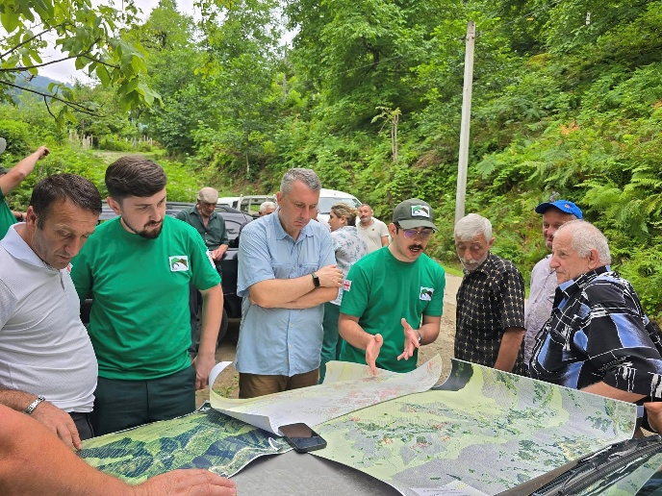 | 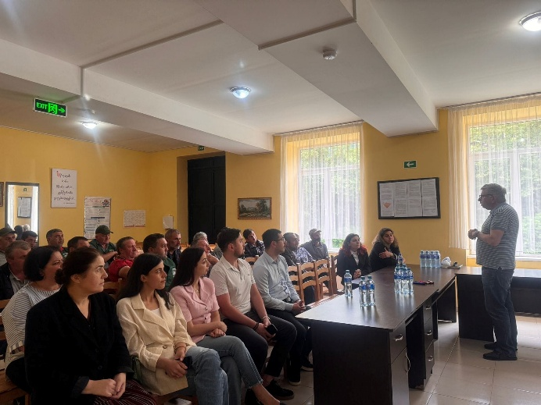
Pic. 1: PL zonation site visit in vil Skurdidi | Pic. 2: Public meeting about Management Plan development process
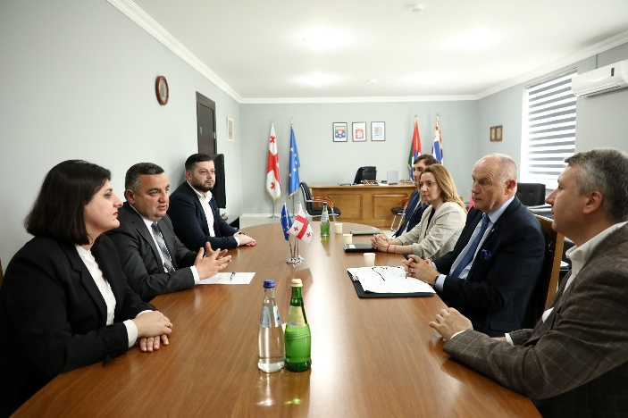 | 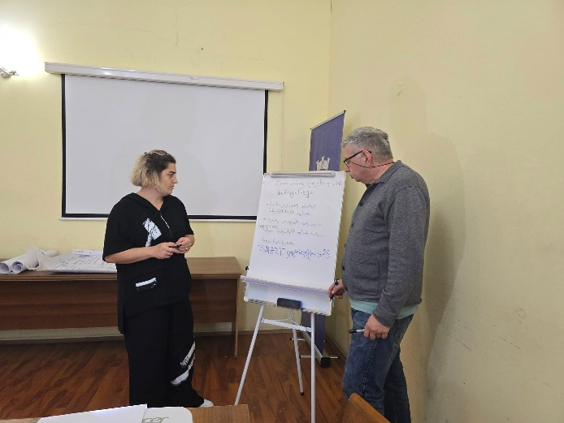
Pic. 3: Meeting of Ambassador Kubernat with the Mayor Diasamidze | Pic. 4: Development of operaitonal plan together with Machakhela PL administration
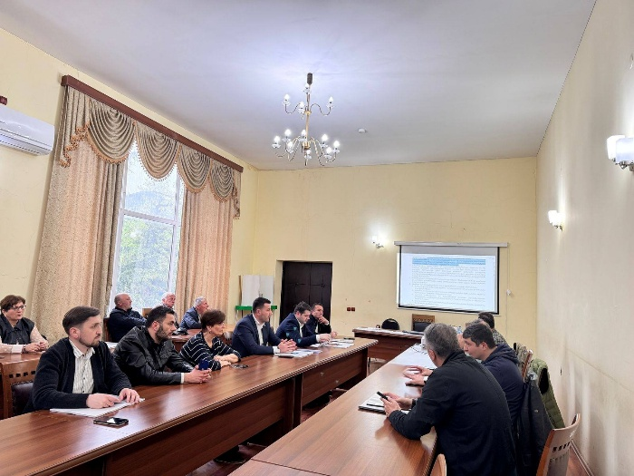 | 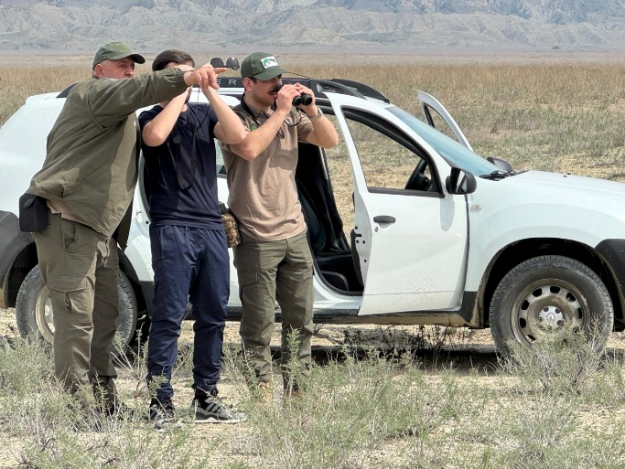
Pic. 5: Machakhela PL Settlement Development Management Guidelines Presentation | Pic. 5: Study visit to the Kaklheti PAs

Annex 2 – Management plan structure
Chapter 1. Introduction
Article 1. Objectives and geographic scope of the management plan
Article 2. Description of the legislative and institutional framework regulating the Machakhela Protected Landscape
Article 3. Goals and objectives of the creation of the Machakhela Protected Landscape
Article 4. Management of the Machakhela Protected Landscape
Article 5. Management plan development process
Article 6. Management plan validity period
Article 7. Amendments and updates to the management plan

Chapter 2. Description of the Machakhela Protected Landscape
Article 8. Location and area
Article 9. Location of Machakhela Protected Areas at the local and international levels
Article 10. History of the Machakhela Protected Landscape
Article 11. Biodiversity,
Article 12. Agrobiodiversity
Article 13. Landscapes and habitats
Article 14. Geology, geomorphology and hydrology
Article 15. Climate
Article 16. Climate change
Article 17. Research - monitoring
Article 18. Ecotourism and recreation
Article 19. Settlement, traditional activities and natural resource use
Article 20. Historical and cultural heritage
Article 21. Environmental education
Article 22. Public relations
Article 23. Ecosystem services
Article 24. Aspects of sustainable socio-economic development
Article 25. Local economy and protected areas of Machakhela Landscape Interconnection
Article 26. Core Values ​​of the Machakhela Protected Landscape
Chapter 3. Analysis of the Current Situation
Article 27. Current Status of the Core Values ​​of the Machakhela Protected Landscape
Article 28. Threats to the Core Values ​​of the Machakhela Protected Landscape
Article 29. Socio-Economic and Urban Development
Article 30. Protection and Use (Management) of Natural Resources
Article 31. Human Resources
Article 32. State of Administration, Infrastructure and Equipment
Article 33. Financing
Article 34. Tourism
Article 35. Eco-Education and Public Relations
Article 36. Partnership and Co-Governance
Article 37. Research-monitoring
Article 38. Invasive species, harmful insects, fungi and diseases

Chapter 4. Long-term goals
Article 39. Goals related to the state of natural ecosystems, landscapes and living organisms
Article 40. Goals related to the state of landscape and cultural diversities resulting from the interaction of human and nature
Article 41. Goals related to the preservation and development of the historical-cultural landscape
Article 42. Goals related to the preservation and integration of cultural heritage
Article 43. Goals related to sustainable socio-economic development for the benefit of the local economy and population
Article 44. Goals related to the sustainable use (management) of natural resources
Article 45. Recreation in the natural and historical-cultural environment, Objectives related to providing favorable conditions for health protection and ecotourism
Article 46. Objectives related to education and awareness-raising
Article 47. Objectives related to science and scientific research
Article 48. Objectives related to participatory management and development of Machakhela Protected Areas as a unified system
Article 49. Objectives related to the development of administration
Chapter 5. Internal zoning
Article 50. Functional zones of the Machakhela Protected Landscape
Article 51. Nature conservation zone
Article 52. Historical-cultural zone
Article 53. Traditional use zone
Article 54. Sustainable development zone
Chapter 6. Management plan programs
Article 55. Law Enforcement Program;
Article 56. Monitoring of Core Values ​​and Threats
Article 57. Fire, Pest, Fungus and Disease Management Program
Article 58. Sustainable Use (Management) of Natural Resources Program
Article 59. Sustainable Socio-Economic and Urban Development Program
Article 60. Sustainable Tourism and Visitor Management Program;
Article 61. Environmental Education Program;
Article 62. Community Relations and Co-Governance Development Program;
Article 63. Historical and Cultural Heritage Program;
Article 64. Administration Capacity Building Program.
Chapter 7. Monitoring the Management Plan
Article 65. Indicators and Basis for Their Selection
Article 66. Monitoring Progress in Implementing the Management Plan Objectives and Actions
Article 67. Procedures and Stages for Monitoring the Management Plan Objectives and Actions
Article 68. Monitoring Plan for Implementing the Management Plan Objectives and Actions
Article 69. Management Plan Monitoring Measures

Appendices

Annex 3 – Financial Report

This process was coordinated with the representative of the Biodiversity and Forestry Policy department of MEPA Ms. Macharashvili, who coordinates the development of the Protected landscapes, including introduction of SMART patrolling in cooperation with the CNF.

